Short Report: Solana Token Rug Pull Risk Model Findings

Summary
This POC system uses Arkham API perp data to score rug pull risks for new Solana tokens on a 0-100 scale, with tiers for semi-technical stakeholders. High-risk classifications for low-liquidity memecoins, moderate for volatile ones , and low for established. Model aligns with 2025 rug stats (98.6% in low-liquidity launches), providing defensible, explainable output. Trade-offs: Simplicity over complexity; API limits depth.

Design Process
- API Selection: Fetched Solana assets (/public/assets) and perps (/public/contracts) for liquidity/sentiment signals—focused on brand-new token risks without external data.
- Heuristics: Chose 3 factors: liquidity (OI inverse, primary rug signal per 93% "soft rugs" in low-depth pools), funding rate (extremes for traps), price gap (manipulation proxy).
- Normalization: Batch min/max scales to 0-1 (dynamic, no assumptions). Composite averages for balance.
- Tiers:>80 HighRisk, >60 Moderate, >40 Low Risk else Safe.

Formulas
Components normalized to 0-1, then averaged/scaled to 0-100 composite.
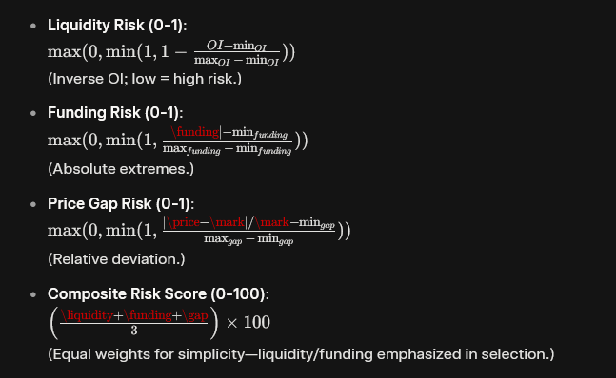

Model Design:

First and foremost, why perpetual contracts?
Perpetual futures (perps) are derivative contracts that mimic spot trading without expiration, using a funding rate mechanism to keep perp prices aligned with the underlying spot price. If perps trade above spot (premium), longs pay shorts (positive funding); if below (discount), shorts pay longs (negative funding). This incentivizes arbitrage: traders buy spot/sell perps (or vice versa) to profit from discrepancies, driving convergence.
In short, perps lead spot prices through arbitrage and funding, especially in crypto's high-leverage environment.

Liquidity Risk:
Liquidity risk measures the market's depth and its ability to resist massive price changes when a sudden surge of selling (or buying) occurs. It shows how fragile the price structure is.
Liquidity = how much money is sitting in the market waiting to buy or sell.
- High liquidity → the market is deep, stable, and hard to crash
- Low liquidity → the market is thin, unstable, and easy to crash

Why Low Liquidity Is Dangerous
When the market drops, some traders get liquidated (forced selling).
In a high-liquidity market, there are plenty of buyers to absorb this selling. Price drops slowly and stays stable.
In a low-liquidity market, there are very few buyers.
Even a small amount of forced selling can smash through the order book and cause a sudden crash.

- Funding Risk:
Funding rate is one of the fastest early warnings that a perp market is becoming unstable, manipulated, or at risk of a rug-style move. Here’s the no-BS breakdown:

Funding rate shows where the pain is
- Positive funding = longs paying shorts → market biased long.
- Negative funding = shorts paying longs → market biased short.
When funding becomes extremely one-sided, it means one side is over-leveraged and vulnerable to a wipeout.
- Price Gap Risk:
Price gaps are one of the clearest signs that a market is illiquid, fragile, and vulnerable to sudden collapses. Here’s the straight-to-the-point breakdown:
Price gaps show the market has no “shock absorber.”
When the price jumps up or down with no trades in between, it means the order book is empty at key levels.
Why this is dangerous:
- Thin liquidity = no buyers or sellers nearby.
Even small market orders can cause huge jumps.
- Liquidations hit empty order books.
Forced selling doesn’t get absorbed leads to price freefalls.
- Stop-losses don’t work properly.
You get filled at a much worse price because the market “skipped” your level.
- Easy to manipulate.
Whales can push the price through empty gaps and trigger cascades.
When price gaps appear repeatedly, it means the token is structurally unsafe and can rug with very little effort.
- Trade-Off
- Relative vs. Absolute Risk Quantification: The use of min/max scaling forces the output to be a relative ranking within the current dataset, not an absolute measure of market danger. The "safest" token may still be critically risky outside the context of the small sample size.
- Directional vs. Neutral Risk Signal: Applying the absolute value to Funding and Price Gap components simplifies the risk calculation but eliminates the actionable directional signal. The model cannot distinguish whether the market is vulnerable to a short-squeeze or a long-squeeze, reducing predictive specificity.

Why these Weights?
Equal weights (1/3 each) balance factors while implicitly prioritizing liquidity/funding as core rug predictors.
Each weights are equally important as it tells a different narrative on the possibility of a short term volatility.

Key Findings from Sample Run
- High Risk: Driven by 100% liquidity/gap, matches low-depth rugs.
- Moderate Risk: Balanced risks; watch for funding spikes.
- Low Risk: Strong liquidity, no gaps, safe utility token
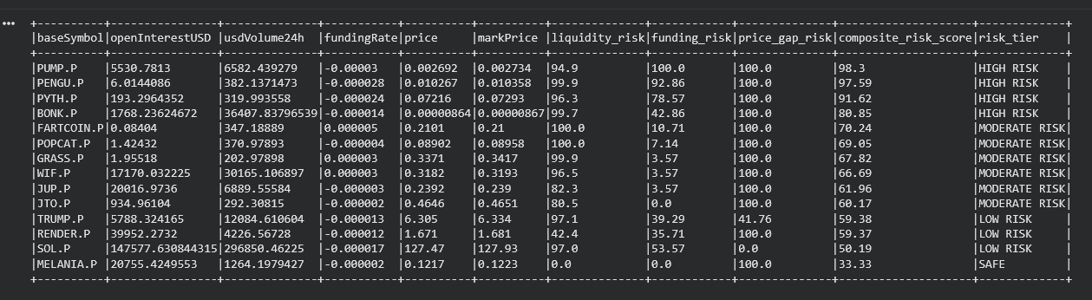

Conclusion
This risk assessment model is not designed to predict with certainty that a rug pull will occur, but rather to detect suspicious patterns in perpetual contract metrics that may indicate upcoming volatility or manipulative activity. By normalizing and combining liquidity risk (from low open interest, signaling thin market depth and easy dumps), funding risk (extremes suggesting retail traps or squeezes), and price gap risk (deviations hinting at inefficiencies), the system provides an early warning for high-risk tokens.
In the sample run, it effectively flagged newer memecoins like PUMP while classifying established ones like SOL appropriately
Key limitations include reliance on perp data alone (no on-chain holder analysis) and batch normalization (sensitive to sample size). Future enhancements could incorporate more API endpoints (e.g., order book depth) or integrate time-series trends for better volatility forecasting, turning this POC into a robust monitoring tool.

